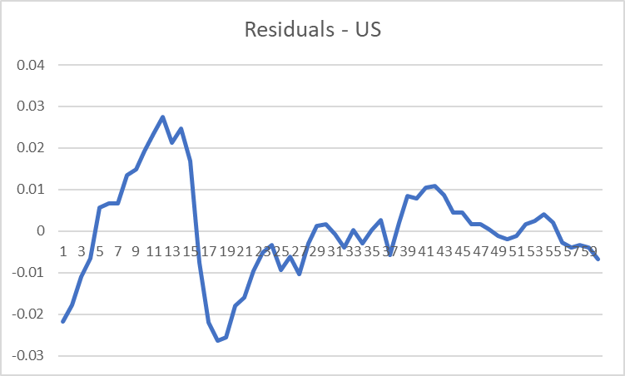

A regression will hit Michigan first.